Modifying Your Email Signature

Open Outlook.

In the Top Left Corner of Outlook, Click **FILE**

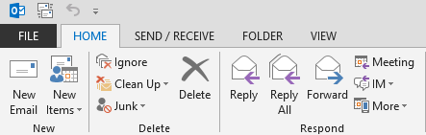

On the Next Screen, click Options

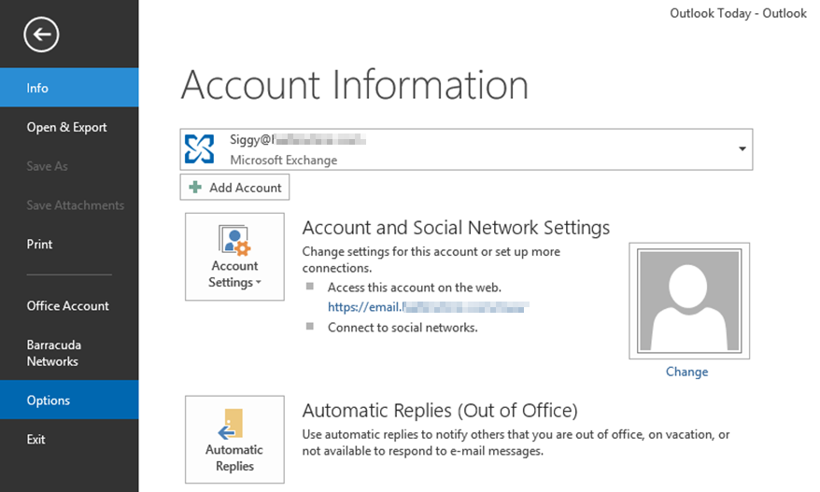

On the **Outlook Options** Dialog click **Signatures**

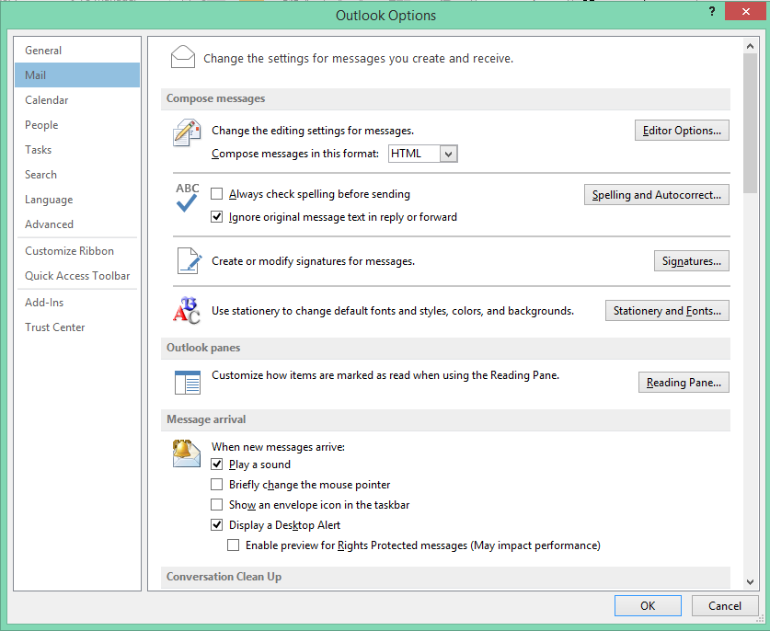

On the **Signatures and Stationary** Dialog,

* Click **Siggy Standard** Signature.
* Edit the Signature to your liking in the box below.
* Click **OK** when you are satisfied.

